1. Copy already existing and working copy of LabVantage N folder where n denotes the first instance and i denotes the ith number of instances that needs to be created and paste with the name as labvantage_n+i instance.



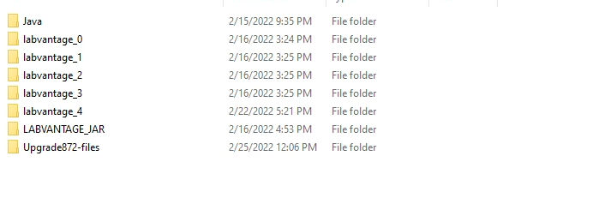

1. Edit labvantage_n+1 🡪 JBOSS_HOME\PROFILE\configuration\standalone.xml (if this is a non-clustered standalone instance) or JBOSS_HOME\PROFILE\configuration\standalone-ha.xml (if this is a clustered standalone instance). Make the changes in steps a through b below before saving it:
   1. Modify the system properties module definition as shown in red below.

<system-properties>

<property name="LABVANTAGE_HOME" value="D:/PROFILE/ labvantage_n+1/labvantagehome87"/>

</system-properties>

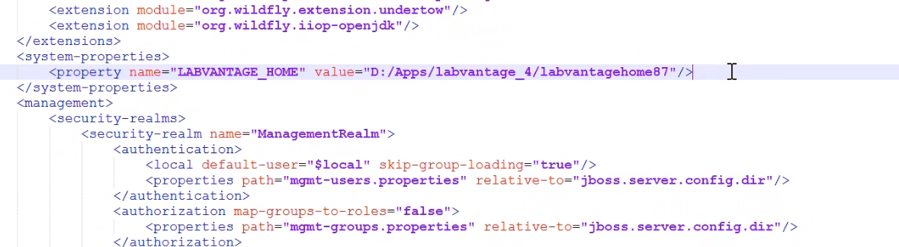

* 1. Modify the socket-binding group module value with port-offset value increased by ith value, e.g., if previously my port-offset value was 1000 and if I’m creating the 4th instance, I’ll set the value to 1004.

LabVantage N:

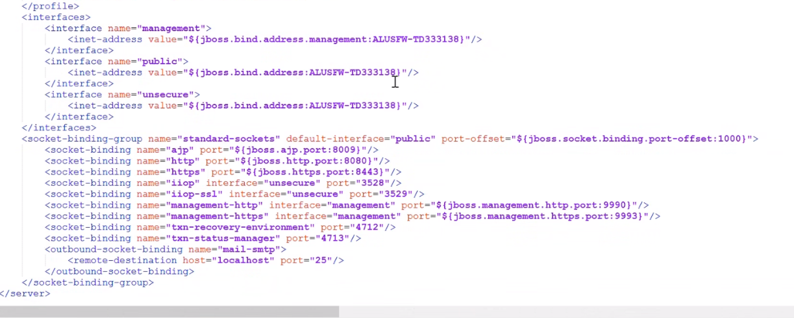

lanvantage_n+i

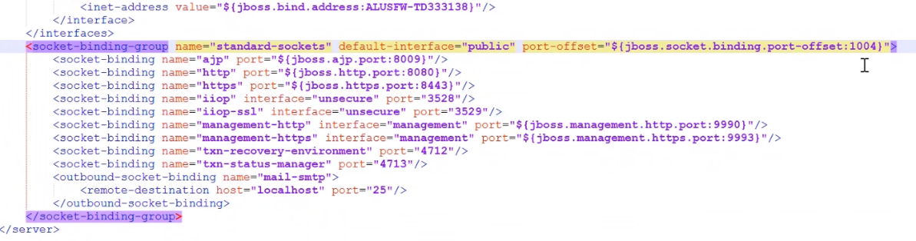

1. Attributes will need to be allowed by modifying JBOSS_HOME\bin\standalone.bat. Open this file using a text editor.
   1. Add the following line marked in red with the appropriate latest available port number (nnnn – denotes the latest available port number) and finally save it before closing the document.

set DEBUG_PORT_VAR=0.0.0.0:<nnnn>

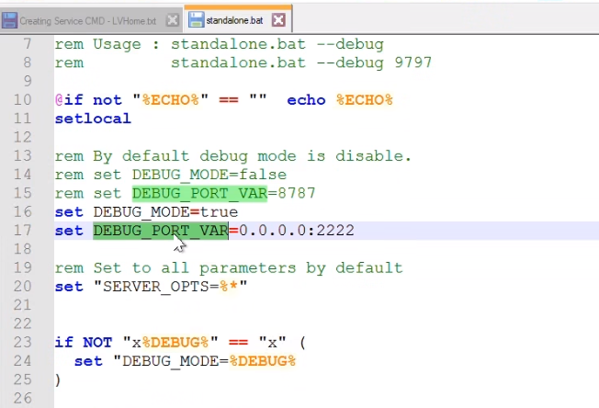

1. Attributes will need to be allowed by modifying JBOSS_HOME\bin\service.bat. Open this file using a text editor.
   1. Modify the following line marked in red with REM at the beginning to comment the entire section so that controller port can be overridden while installing the service.

rem set CONTROLLER=localhost:9990

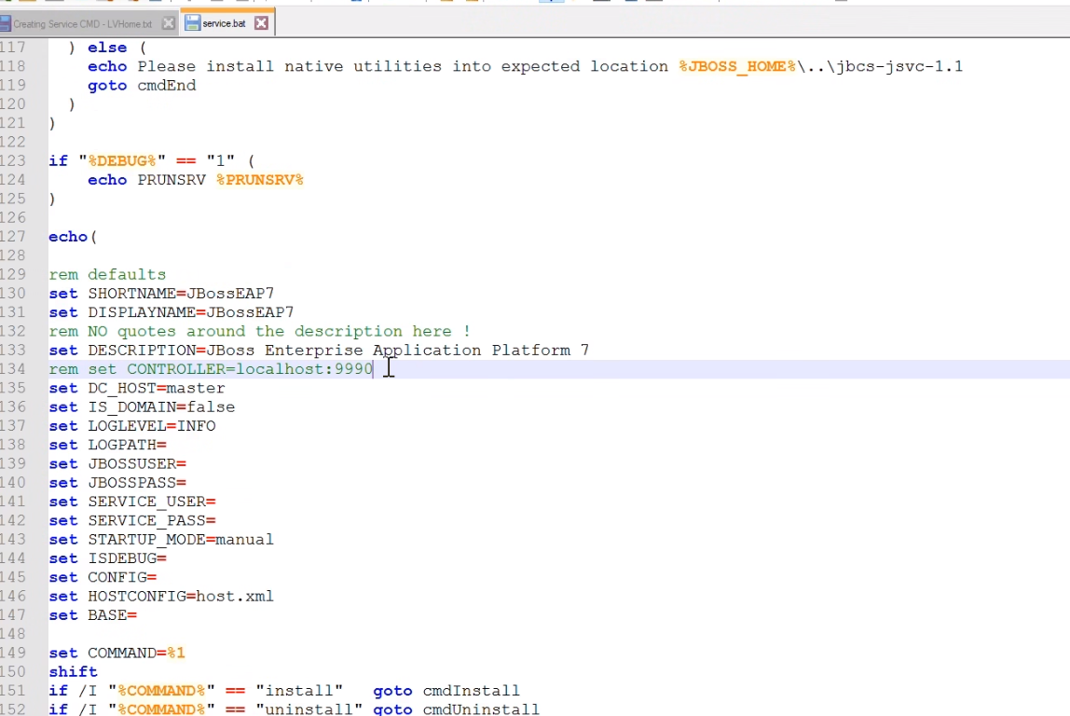

1. Attributes will need to be allowed by modifying JBOSS_HOME\bin\standalone.conf.bat. Open this file in text editor. Modify the JAVA_HOME path from LabVantage to labvantage_n+I instance as shown in red line below:

set "JAVA_HOME=D:\Apps\labvantage_4\Java\openjdk-11.0.10.9-1"

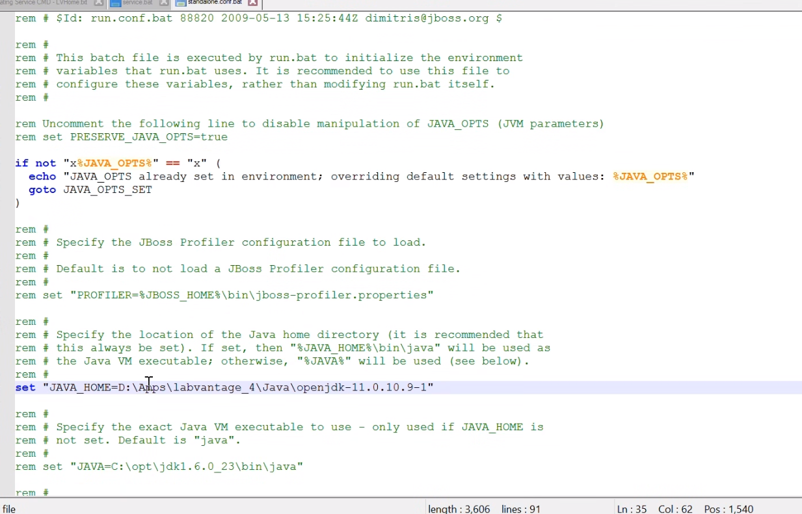

1. In a Command window running as an Administrator, run this command from the JBOSS_HOME\bin directory and once the service is installed, the general property needs to be modified for Startup Type to Automatic (Delayed Start).

service install /name NAME /desc “DESCRIPTION” /base JBOSS_HOME\PROFILE /config CONFIG /controller MGMTINT /jbossuser JBOSSUSER /jbosspass PASSWORD

